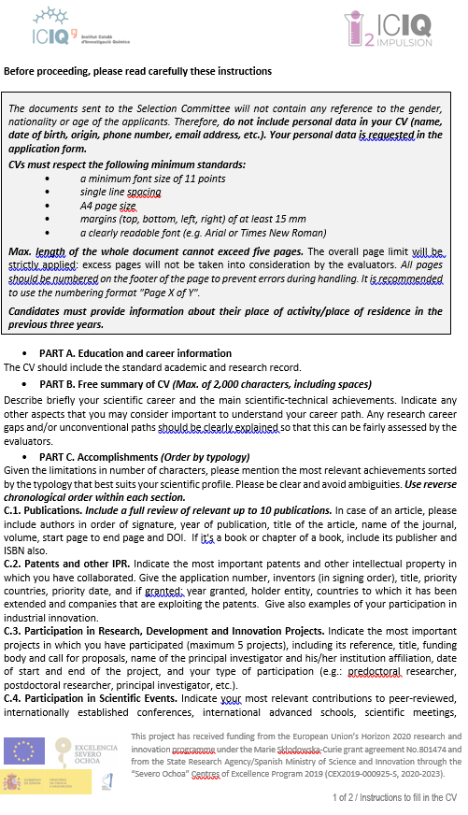
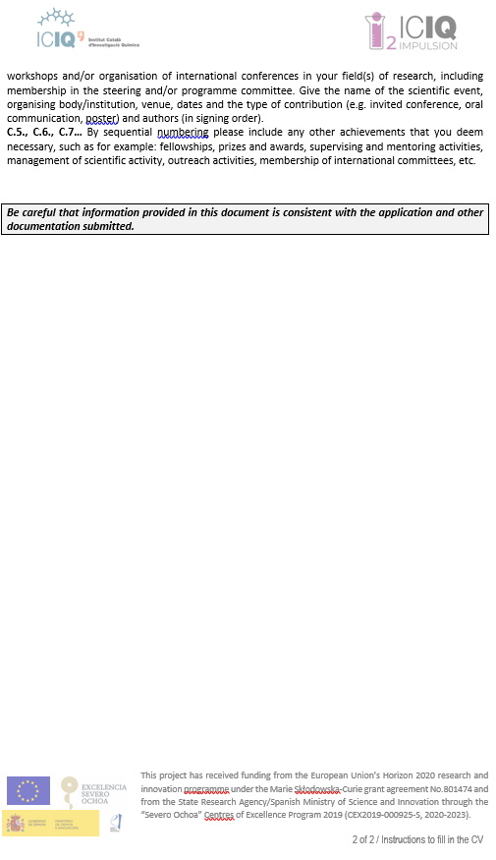

Curriculum Vitae Date: dd/mm/yyy

Project topic Reference: ICIQ-
Country of activity/residence in the last 3 years as of 5 September 2021:
Place of activity/place of residence (previous 3 years - most recent one first)
Period from | Period to | Duration (months) | Country
dd/mm/yyyy | dd/mm/yyyy
dd/mm/yyyy | dd/mm/yyyy
dd/mm/yyyy | dd/mm/yyyy
Total (months)

Part A. Education and Career Information

A.1. Professional experience (Provide the information in reverse chronological order, using exact dates)
Position/
Professional Category
Keywords
University/Institution
Department/Centre/Institute
Address
Start date - End date
Position/
Professional Category
Keywords
University/Institution
Department/Centre/Institute
Address
Start date - End date
More entries can be added if needed.

A.2. Education (Provide the information in reverse chronological order, using exact dates)
Doctorate
PhD Thesis Title
PhD Supervisor
University/Institution
Country
Start date
Date the PhD was secured through successful defence
Other university degree(s)/master(s), if any, obtained after the first university degree
Title
University/Institution
Country
Date of award
Title
University/Institution
Country
Date of award
More entries can be added if needed.

First university degree
Title
University/Institution
Country
Date of award

Part B. Free Summary of CV (Max. of 2,000 characters, including spaces. Please delete the instructions provided below)

Describe briefly your scientific career and the main scientific-technical achievements.
Indicate any other aspects that you may consider important to understand your career path. Any research career gaps and/or unconventional paths should be clearly explained so that this can be fairly assessed by evaluators.

Part C. Relevant Accomplishments (Use reverse chronological order within each section. Please delete the instructions provided for each point)

C.1. Publications
Up to ten publications in peer-reviewed scientific journals, peer-reviewed conference proceedings, monographs of their respective research fields and/or chapters in collective volumes, indicating also the number of citations they have attracted.
In case of an article, please include authors in order of signature, year of publication, title of the article, name of the journal, volume, start page to end page and DOI. If it's a book or chapter of a book, include its publisher and ISBN also.

C.2. Patents and other IPR
Indicate the most important patents and other intellectual property in which you have collaborated (maximum 5). Give the application number, inventors (in signing order), title, priority countries, priority date, and if granted: year granted, holder entity, countries to which it has been extended and companies that are exploiting the patents. Give also examples of your participation in industrial innovation.

C.3. Participation in Research, Development and Innovation Projects

Indicate the most important projects in which you have participated (maximum 5 projects), including its reference, title, funding body and call for proposals, name of the principal investigator and his/her institution affiliation, date of start and end of the project, and your type of participation (e.g.: predoctoral researcher, postdoctoral researcher, principal investigator, etc.).

C.4. Participation in Scientific Events
Indicate your most relevant contributions to peer-reviewed, internationally established conferences, international advanced schools, scientific meetings, workshops and/or organisation of international conferences in your field(s) of research, including membership in the steering and/or programme committee (maximum 10). Give the name of the scientific event, organising body/institution, venue, dates and the type of contribution (e.g. invited conference, oral communication, poster) and authors (in signing order)

C.5, C.6, C.7… Other (Explain any other activities or aspects you wish to highlight from your CV that have not been covered in the previous sections)
By sequential numbering (C.5, C.6, C.7 ...) please include any other achievements that you deem necessary, such as for example: fellowships, prizes and awards, supervising and mentoring activities, management of scientific activity, outreach activities, membership of international committees, etc.

STOP PAGE COUNT – MAX 5 PAGES ––––––––––––––––––––––––––––––––––––––––––

