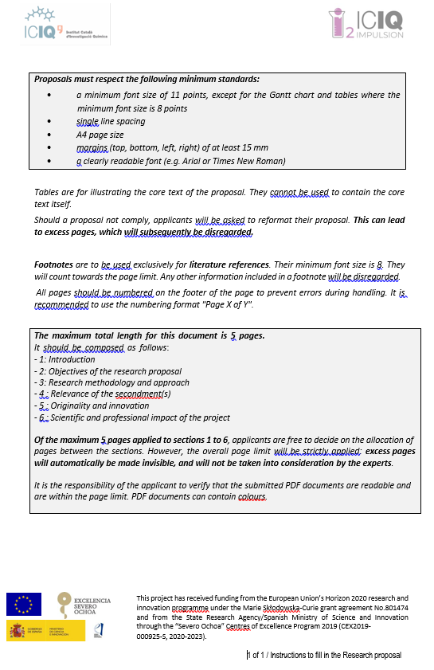

Research Project Proposal

Project topic Reference: ICIQ-

Acronym and Title:

Keywords (Please select up to 5 key words (and at least 3) that best characterise the subject of your proposal, in descending order of relevance):

Abstract (maximum 2000 characters including spaces):

START PAGE COUNT–MAX 5 PAGES–DO NOT ADD INTRODUCTORY PAGES BEFORE

1. Introduction: Explain why the research topic is important and justify the need for conducting the research.

2. Objectives of the research proposal: Explain clearly what the project aims to achieve. If necessary, break down the general objective(s) into specific objectives.

3. Research methodology and approach: Describe how the work planning (including deliverables and milestones) will ensure that the research objectives will be reached.

Describe the planned secondment(s) and how the experience of a different research environment will add/complement the research you want to develop at ICIQ.

A Gantt chart should be included with a list of milestones and deliverables.

4. Relevance of the secondment(s): Describe the needs and benefits of the secondment justifying the partner institution chosen and the alignment with the project objectives.

5. Originality and innovation: Explain the originality and innovative aspects of the planned research as well as the contribution that the action is expected to make to advancements within the research field. Describe any novel concepts, approaches or methods that will be implemented.

6. Scientific and professional impact of the project: Explain the expected impact of the planned research and training (i.e. the added value of the fellowship) on the future career prospects of the experienced researcher and on the research field.

STOP PAGE COUNT – MAX 5 PAGES

